**Enhanced Beef Industry Awareness, Literacy, and Advocacy through Livestock Evaluation and Competition at Virginia Tech**

*Virginia Tech’s School of Animal Sciences, under leadership of Professor Matthew Miller has embarked on an initiative to enhance livestock evaluation, aiming to educate and empower the next generation of beef industry advocates and leaders. After a period of inactivity and lower participation, the university, with assistance from partners such as the Virginia Cattle Industry Board, has reinvested in livestock evaluation, providing students with hands-on experience in cattle selection, valuation, and public speaking.*

**A Renewed Focus on Industry Literacy** With approximately 700 undergraduates enrolled in the School of Animal Sciences, Virginia Tech recognizes the potential to cultivate a knowledgeable and engaged student body that can contribute to the beef industry. The Livestock Evaluation program not only sharpens students’ technical skills in cattle selection but also hones their ability to advocate for and communicate about the industry effectively.

Through rigorous practice, participation in competitions, and industry-related travel, students develop an in-depth understanding of the beef cattle sector. This initiative aims to create well-rounded individuals who can take on leadership roles and drive innovation within the industry.

**Competitive Edge and Experiential Learning** Students who successfully complete the prerequisite course will have the opportunity to join the Virginia Tech Collegiate Livestock Judging Team. This team will compete in multiple contests across the country, gaining valuable hands-on experience.

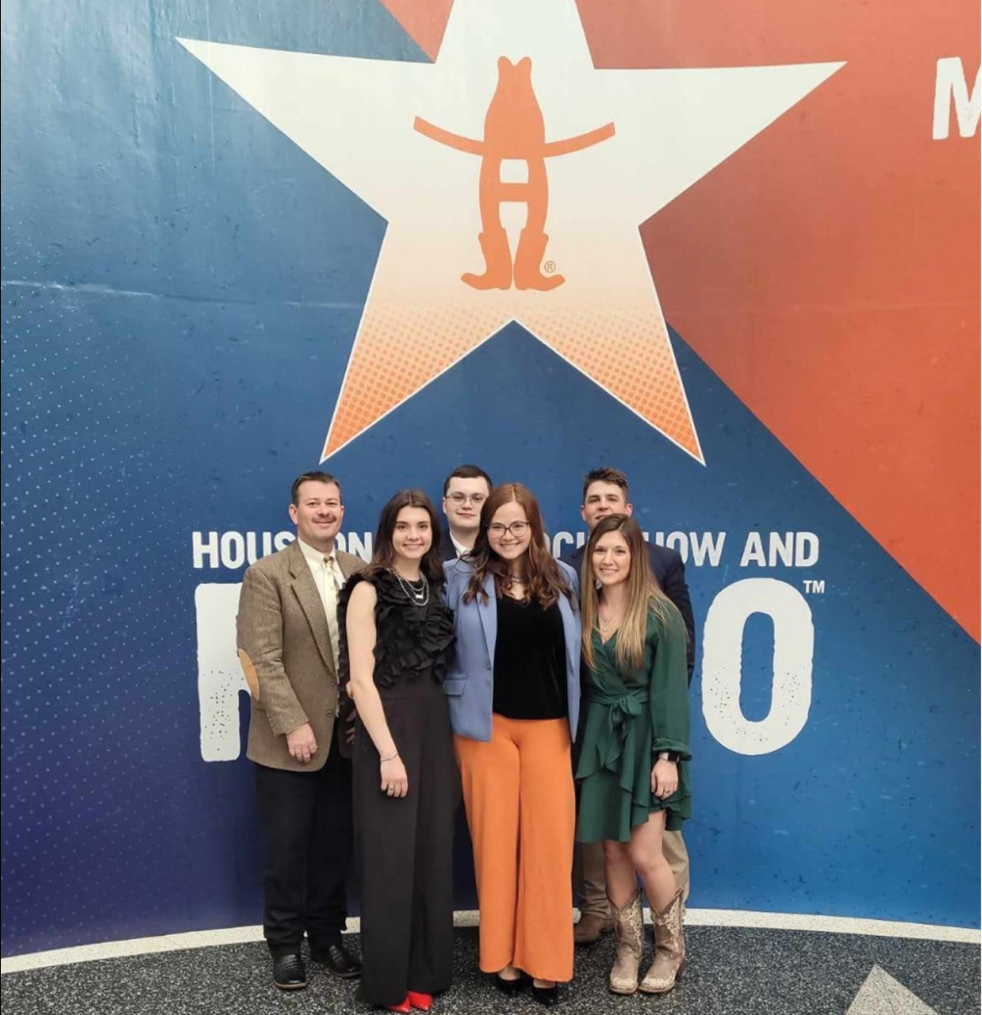

Photo: Houston Livestock Show and Rodeo 2024, From L-R: Matthew Miller, Salem Sifford, Tanner Wise, Megan Mallory, Parker Epperley, Aubrey Long

Some Competitions attended in 2024 included:

* + National Western Stock Show (Denver, CO)
  + Houston Livestock Show and Rodeo (Houston, TX)
  + All-East Contest (Starkville, MS)
  + Prof Lidvall Competition (TN)
  + Keystone Livestock Expo (Harrisburg, PA)
  + Boilermaker at Purdue (IN)

The initiative, supported in part by the Virginia Cattle Industry Board (VCIB), provides critical funding for travel expenses for the competitors. These resources ensure students can participate without financial barriers, allowing them to focus on gaining industry knowledge and refining their skills.

**A Future Built on Knowledge and Advocacy** Virginia Tech’s renewed emphasis on livestock evaluation represents a commitment to fostering future industry leaders. By equipping students with practical experience, public speaking abilities, and industry insight, the program aims to ensure Virginia’s beef industry remains strong, well-informed, and adaptive to evolving challenges.

With competition experience and exposure to real-world industry operations, these students will be well-positioned to make significant contributions to the future of the beef industry.

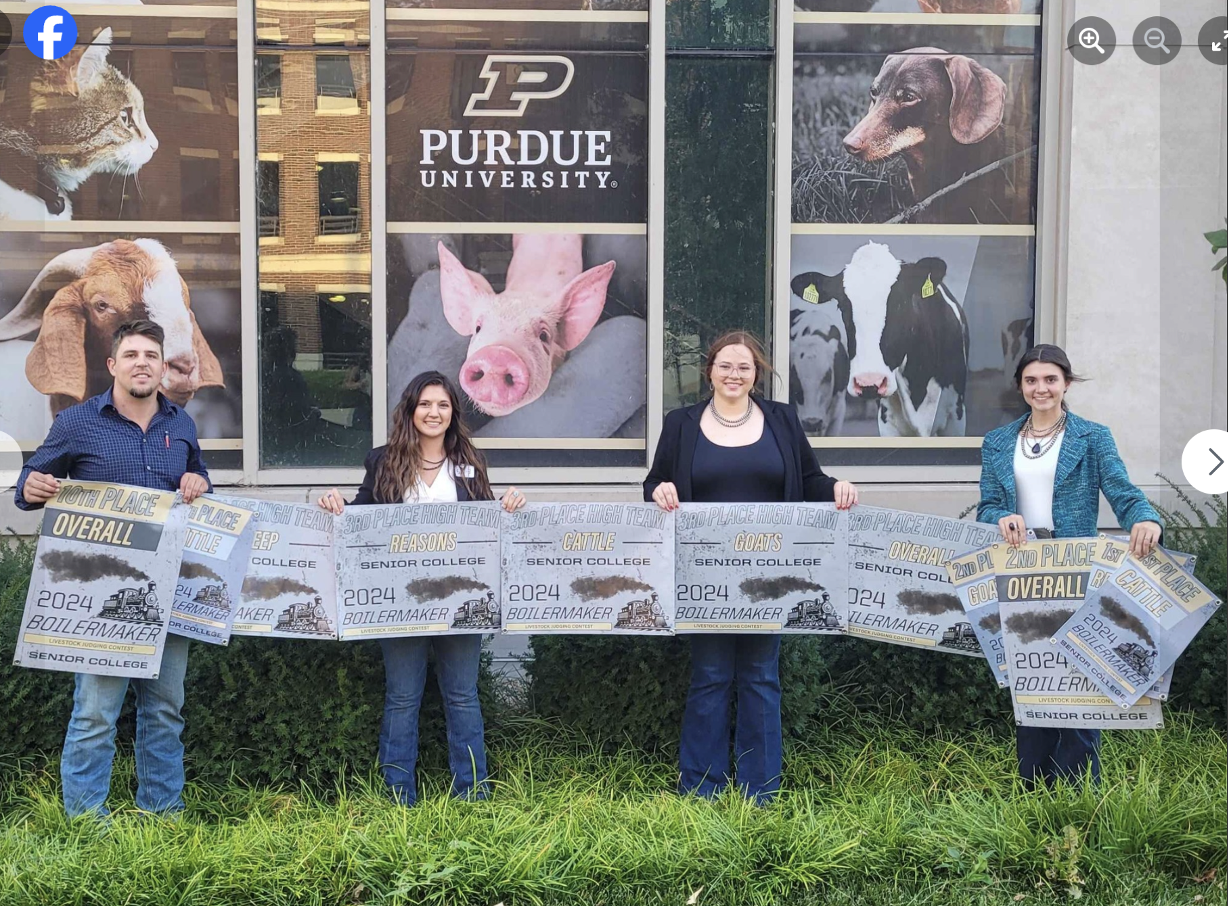

Photo: Boilermaker, Purdue University, 2024: Parker Epperley, Aubrey Long, Megan Mallory, Salem Sifford